Note: Please leave this on the ambo, thanks.
HOLY THURSDAY - YEAR C

Introduction
Good evening we welcome our parishioners and visitors to Mary Immaculate Quakers Hill/Schofields Parish.

Dear brothers and sisters, tonight we begin the Paschal Triduum: the Passion, Death, and Resurrection of our Lord Jesus Christ. On this most solemn hour, Jesus left us a memorial of two symbolic gestures of his love for us: the giving of his own body and blood in the form of bread and wine, and his act of washing the feet of his disciples.

These two remind us that the supreme act of love is manifested through total self-giving of oneself for the beloved, just as what Jesus did when he freely offered his life on the Cross for our sake; and to challenge us to strip away our clothes of self-entitlement, honours, and pride, and to serve one another out of love for each other and out of love for God.

Our Mass will be celebrated today by: Fr. Oliver and Fr. Ever

Please stand and join in singing the Entrance Hymn.

holy thursday - Year C
LITURGY OF THE WORD

FIRST READING Ex 12:1-8. 11-14

A reading from the book of Exodus
The Lord said to Moses and Aaron in the land of Egypt, ‘This month is to be the first of all the others for you, the first month of your year. Speak to the whole community of Israel and say, “On the tenth day of this month each man must take an animal from the flock, one for each family: one animal for each household. If the household is too small to eat the animal, a man must join with his neighbour, the nearest to his house, as the number of persons requires. You must take into account what each can eat in deciding the number for the animal. It must be an animal without blemish, a male one year old; you may take it from either sheep or goats. You must keep it till the fourteenth day of the month when the whole assembly of the community of Israel shall slaughter it between the two evenings. Some of the blood must then be taken and put on the two doorposts and the lintel of the houses where it is eaten. That night, the flesh is to be eaten, roasted over the fire; it must be eaten with unleavened bread and bitter herbs. You shall eat it like this: with a girdle round your waist, sandals on your feet, a staff in your hand. You shall eat it hastily; it is a passover in honour of the Lord. That night, I will go through the land of Egypt and strike down all the first-born in the land of Egypt, man and beast alike, and I shall deal out punishment to all the gods of Egypt, I am the Lord. The blood shall serve to mark the houses that you live in. When I see the blood I will pass over you and you shall escape the destroying plague when I strike the land of Egypt. This day is to be a day of remembrance for you, and you must celebrate it as a feast in the Lord’s honour. For all generations you are to declare it a day of festival, for ever.”’

The Word of the Lord.

RESPONSORIAL PSALM Ps Ps 115:12-13. 15-18. R. cf. 1 Cor 10:16

(R.) Our blessing-cup is a communion with the blood of Christ.

1. How can I repay the Lord
for his goodness to me?
The cup of salvation I will raise;
I will call on the Lord’s name. (R.)

2. O precious in the eyes of the Lord

is the death of his faithful.

Your servant, Lord, your servant am I;

you have loosened my bonds. (R.)

3. A thanksgiving sacrifice I make:

I will call on the Lord’s name.

My vows to the Lord I will fulfil

before all his people. (R.)

SECOND READING (1Cor 11:23-26)

A reading from the first letter of St Paul to the Corinthians

This is what I received from the Lord, and in turn passed on to you: that on the same night that he was betrayed, the Lord Jesus took some bread, and thanked God for it and broke it, and he said, ‘This is my body, which is for you; do this as a memorial of me.’ In the same way he took the cup after supper, and said, ‘This cup is the new covenant in my blood. Whenever you drink it, do this as a memorial of me.’ Until the Lord comes, therefore, every time you eat this bread and drink this cup, you are proclaiming his death.

The Word of the Lord.

GOSPEL ACCLAMATION
Praise and honour to you, Lord Jesus Christ!
I give you a new commandment:
love one another as I have loved you.
Praise and honour to you, Lord Jesus Christ!

GOSPEL (Jn 13:1-15)

A reading from the holy Gospel according to John

It was before the festival of the Passover, and Jesus knew that the hour had come for him to pass from this world to the Father. He had always loved those who were his in the world, but now he showed how perfect his love was.

They were at supper, and the devil had already put it into the mind of Judas Iscariot son of Simon, to betray him. Jesus knew that the Father had put everything into his hands, and that he had come from God and was returning to God, and he got up from table, removed his outer garment and, taking a towel, wrapped it round his waist; he then poured water into a basin and began to wash the disciples’ feet and to wipe them with the towel he was wearing.

He came to Simon Peter, who said to him, ‘Lord, are you going to wash my feet?’ Jesus answered, ‘At the moment you do not know what I am doing, but later you will understand.’ ‘Never!’ said Peter. ‘You shall never wash my feet.’ Jesus replied, ‘If I do not wash you, you can have nothing in common with me.’ ‘Then, Lord,’ said Simon Peter, ‘not only my feet, but my hands and my head as well!’ Jesus said, ‘No one who has taken a bath needs washing, he is clean all over. You too are clean, though not all of you are.’ He knew who was going to betray him, that was why he said, ‘though not all of you are.’

When he had washed their feet and put on his clothes again he went back to the table. ‘Do you understand’ he said ‘what I have done to you? You call me Master and Lord, and rightly; so I am. If I, then, the Lord and Master, have washed your feet, you should wash each other’s feet. I have given you an example so that you may copy what I have done to you.’

The Gospel of the Lord.

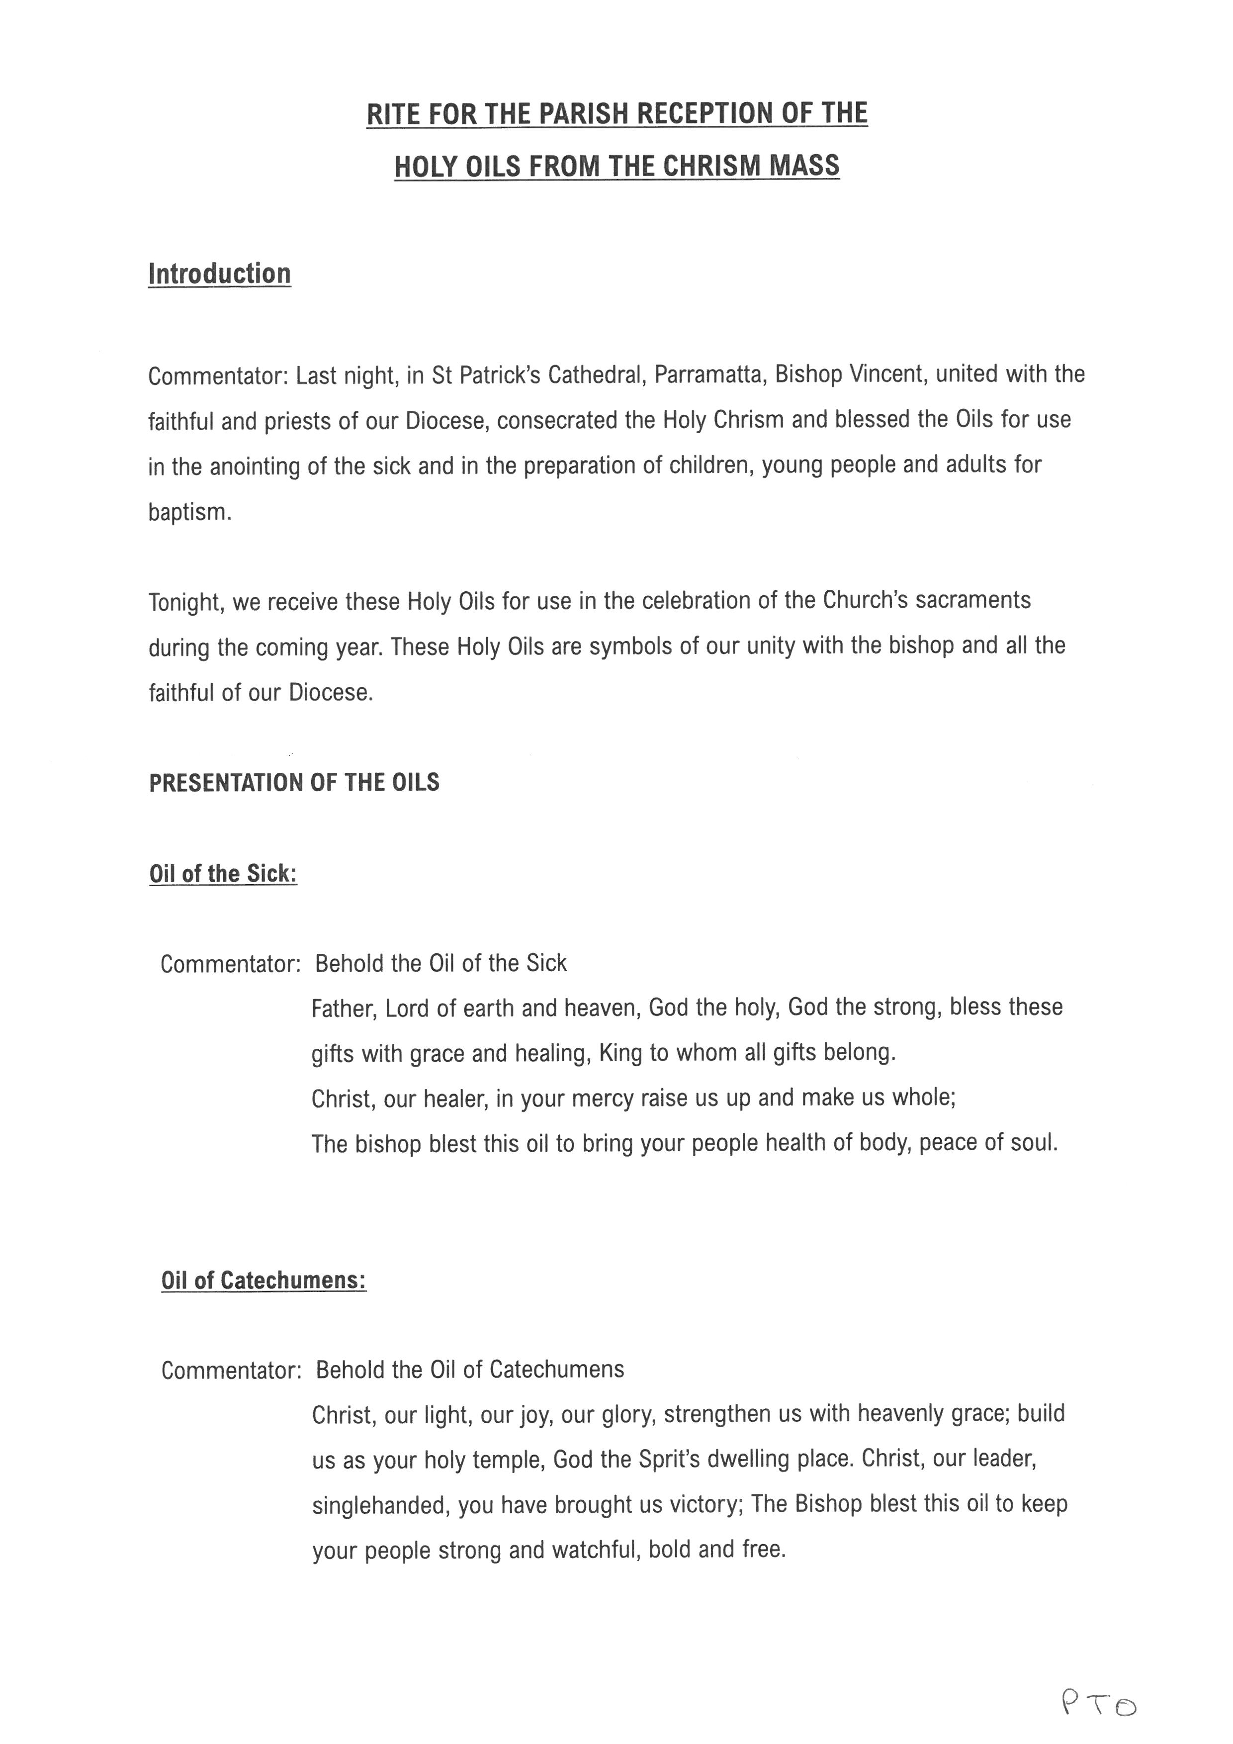
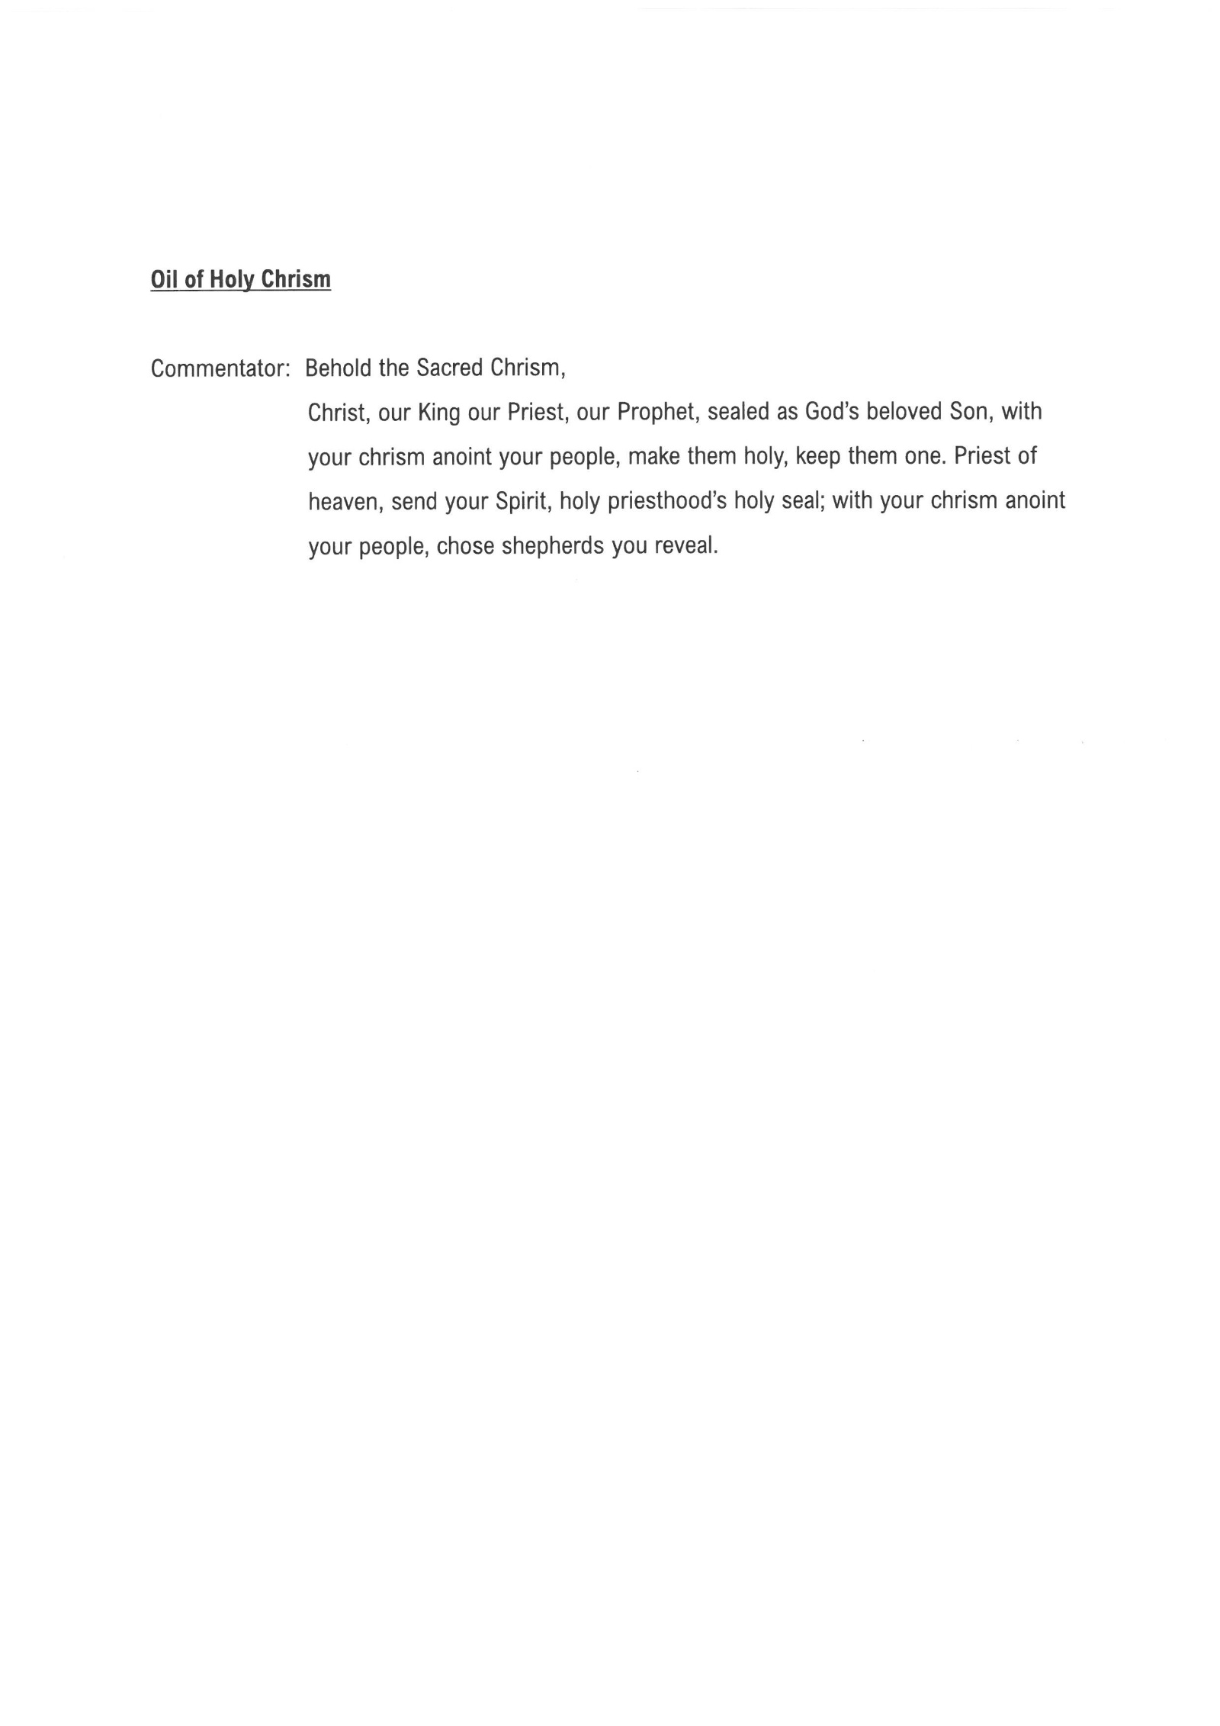

HOLY THURSDAY - YEAR C
GENERAL INTERCESSION

Priest: — At the Last Supper, the Lord Jesus gave us the Eucharist as the memorial of his self-offering and suffering. Let us ask the Father that we may believe in the mystery that the Eucharist signifies.

Reader: — May the Church leaders gather the pains, struggles, and hopes of humanity and join them to Christ’s offering.
We pray:

R — Lord, hear our prayer.

Reader: May all Christians always remain united to Christ in prayer, in sacrifice, and in service.
We pray:

R — Lord, hear our prayer.

Reader: May our government and civil leaders follow the example of Christ who choose to serve rather than be served. May they always strive after the common welfare of the people.
We Pray:

R — Lord, hear our prayer.

Reader: May the sick, the handicapped, the abandoned, and the oppressed unite their pains and sufferings to Christ’s through their participation in the Eucharist.
We pray:

R — Lord, hear our prayer.

Reader: May the youth believe in Christ’s Paschal Mystery by uniting themselves to God and offering their own lives through humble service and compassion with one another.
We pray.
R — Lord, hear our prayer.

Reader: For those who have died. In particular, those mention in our parish bulletin. May God’s merciful love shine on them and their loved ones left behind.
We pray.
R — Lord, hear our prayer.

Reader: Together we now pray our Parish community prayer for Holy Thursday:

All: Loving Father, you gather us in this upper room with your son, to be fed by your love. At that supper, Jesus told us to "love one another" and we know that is the heart of his gift, his sacrifice for us. We ask that we might find the source of our own heart, the meaning for our own lives, in that Eucharist. Guide us to the fullness of your love and life.

Priest: Heavenly Father, giver of life and of all that is good, hear our prayers and look upon us with kindness. As we celebrate the memorial of Christ’s passion and death, bring us to the glory of his resurrection. This we ask through Christ our Lord.

All: Amen.

