Novena Simbang Gabi &
Dawn Mass
IN HONOUR OF
THE BLESSED VIRGIN MOTHER
IN PREPARATION FOR CHRISTMAS.


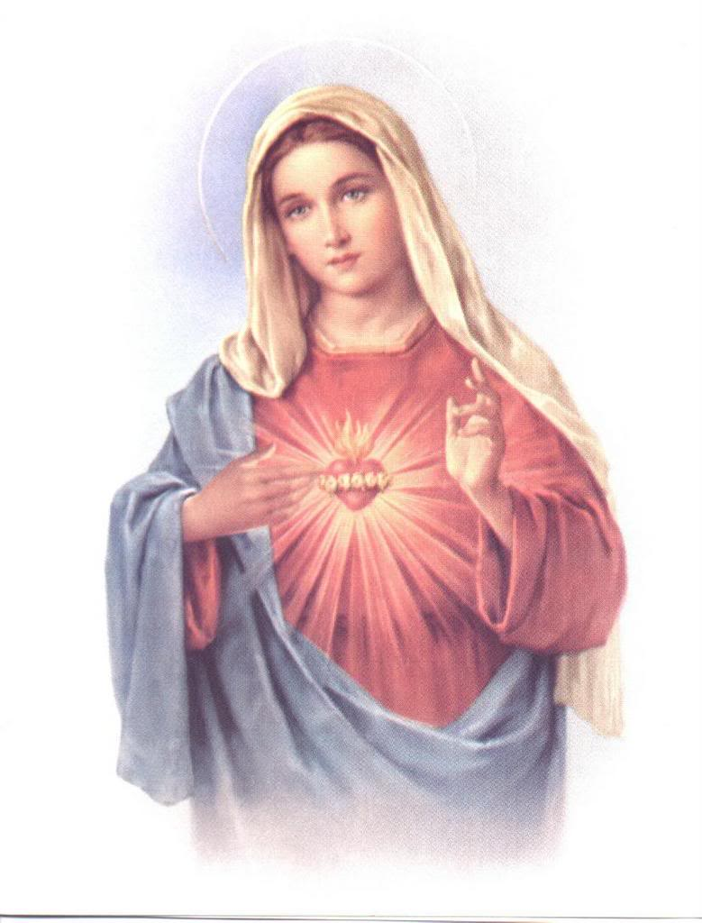

Mary Immaculate Parish Quakers Hill
Seventh Novena Mass
Celebrant
4.30am ~ Fr. Jessie Balorio
7.00pm ~Fr. Ever

READER’S COPY
Novena Simbang Gabi &
Dawn Mass
IN HONOUR OF
THE BLESSED VIRGIN MOTHER
IN PREPARATION FOR CHRISTMAS.

Mary Immaculate Parish Quakers Hill
Seventh Novena Mass
Celebrant
4.30am ~ Fr. Jessie Balorio
7.00pm ~Fr. Ever

PRIEST’S COPY
Novena Simbang Gabi &
Dawn Mass

IN HONOUR OF
THE BLESSED VIRGIN MOTHER
IN PREPARATION FOR CHRISTMAS.

Mary Immaculate Parish Quakers Hill
Seventh Novena Mass
Celebrant
4.30am ~ Fr. Jessie Balorio
7.00pm ~Fr. Ever
COMMENTATOR’S COPY
Note: Please leave this on the ambo, thanks.

Seventh Novena Mass
Introduction

Good Morning / Evening and welcome to the parish of Mary Immaculate Quakers Hill – Schofields.

Today’s Gospel focuses on Mary’s song of praise, the Magnificat. Here Mary narrates how God intervenes in the history of mankind. The Magnificat is not only a song but a prophetic word and witness. What the Lord has done for Mary, he will also do for all of us, his people. May our Eucharistic celebration remind us of all the good things God has done for us in our lives, and sing our own Magnificat. We especially pray for young people, that in the midst of the pessimism and nihilism of the modern world they too may sing, “My soul proclaims the greatness of the Lord!”

Our Mass will be celebrated today by 4.30am ~ Fr. Jessie Balorio

7.00pm ~Fr. Ever

SEVENTH NOVENA MASS
YEAR B
LITURGY OF THE WORD

FIRST READING: 1 Sm 1:24-28
A reading from the first book of Samuel

When Hannah had weaned Samuel, she took him up with her together with a three-year old bull, an ephah of flour and a skin of wine, and she brought him to the temple of the Lord at Shiloh; and the child was with them. They slaughtered the bull and the child’s mother came to Eli. She said, ‘If you please, my lord. As you live, my lord, I am the woman who stood here beside you, praying to the Lord. This is the child I prayed for, and the Lord granted me what I asked him. Now I make him over to the Lord for the whole of his life. He is made over to the Lord.’
There she left him, for the Lord.

The Word of the Lord.

RESPONSORIAL PSALM (1 Sm 2:1. 4-8. R. v.1)
R.) My heart rejoices in the Lord, my Saviour.

- My heart exults in the Lord,
I find my strength in my God;
my mouth laughs at my enemies
as I rejoice in your saving help. (R.)

- The bows of the mighty are broken,
but the weak are clothed with strength.
Those with plenty must labour for bread,
but the hungry need work no more.
The childless wife has children now
but the fruitful wife bears no more. (R.)

- It is the Lord who gives life and death,
he brings men to the grave and back;
it is the Lord who gives poverty and riches.
He brings men low and raises them on high. (R.)

- He lifts up the lowly from the dust,
from the dungheap he raises the poor
to set him in the company of princes,
to give him a glorious throne.
For the pillars of the earth are the Lord’s,
on them he has set the world. (R.)

GOSPEL ACCLAMATION
Alleluia, alleluia!
Come,
King of all nations,
source of your Church’s unity and faith:
save all people, your own creation!
Alleluia!

GOSPEL Lk 1:46-56
A reading from the holy Gospel according to Luke.

Mary said:
‘My soul proclaims the greatness of the Lord
and my spirit exults in God my saviour;
because he has looked upon his lowly handmaid.
Yes, from this day forward all generations will call me blessed,
for the Almighty has done great things for me.
Holy is his name,
and his mercy reaches from age to age for those who fear him.
‘He has shown the power of his arm,
he has routed the proud of heart.
He has pulled down princes from their thrones and exalted the lowly.
The hungry he has filled with good things, the rich sent empty away.
He has come to the help of Israel his servant, mindful of his mercy
– according to the promise he made to our ancestors –
of his mercy to Abraham and to his descendants for ever.’
Mary stayed with Elizabeth about three months and then went back home.

The Gospel of the Lord.

SEVENTH NOVENA MASS
YEAR B

GENERAL INTERCESSIONS

Celebrant: As we make Mary’s Magnificat our own song, let us pray to the Father that this coming Christmas we may proclaim the joy caused by God’s mercy and power.

Reader: May the Church strive to be a Church of the Poor, where the poor, equal to all others in Christian dignity, not only are evangelized but become evangelizers themselves.
We pray.
All: R— Lord, hear our prayer.

Reader: May those who serve in public office cast down the culture of wastefulness, violence, and corruption; may they seek the common good and practice transparency and accountability in governance.
We pray.
All: R— Lord, hear our prayer.

Reader: May those who work for justice and serve the weak, the poor, and the marginalized, persevere in their work, knowing that they bring God’s love among the people.
We pray.
All: R— Lord, hear our prayer.

Reader: May our family members, relatives, and friends who have died experience everlasting joy in the company of our Lord and Saviour, Jesus Christ, especially remembering all those mentioned in our parish bulletin and whose anniversary occurs at this time.
We pray.
All: Lord, hear our prayer.

Reader: Together we now pray our Parish Community prayer during Advent.
All: God of hope, who brought love into this world, be the love that dwells between us.
God of hope, who brought peace into this world, be the peace that dwells between us.
God of hope, who brought joy into this world, be the joy that dwells between us.
God of hope, the rock we stand upon, be the centre, the focus of our lives always, and particularly this Advent time.

Celebrant: Father, listen with compassion to the prayer of your church. May what we entreat you help us to proclaim always your mighty deeds with joy and sincere hearts. We ask this through Christ our Lord.
All: Amen.

